Inlet Air Temperature Gauge Display – CGEA1.3

Functional Description

The purpose of the Inlet Air Temperature gauge display is to provide a digital and graphical read out of the temperature of the air in the cold air inlet tube.

The air temperature is measured by the PCM. The Inlet Air Temperature Gauge display correlates the EngAirIn_Te_Actl signal on the CAN bus from the PCM and the Operational Mode to display the temperature in degrees Fahrenheit or degrees Celcius, depending on the selected units.

The PCM is responsible for any filtering of the data and the Instrument cluster only needs to display the information it receives. The Instrument cluster is responsible for any scaling or unit changes that are required. The Inlet Air temperature shall follow the globally selected units and display its value in either English or Metric units. The display range should be 0 degrees F to 240 degrees F (-20 degrees C to 120 degrees C) with linear scaling. The virtual gauge sweep shall be 218 degrees with chaplets every 10 degrees F (10 Degrees C) and numerical indication every 40 degrees F (20 degrees C). This gauge does not require any red indications because it does not provide warning of any fault condition.

There is a digital numeric and graphical virtual gauge that displays the temperature of the air in the cold air inlet tube. The Inlet Air Temperature Gauge pointer shall rotate from bottom to top or left to right to register increasing temperature and rotate in the opposite direction for decreasing temperature.

Interfaces

Interface Context Diagram (I/O Block Diagram)
Inlet Air Temperature Gauge Display Context Diagram

Inputs

IR-REQ-298762/A-Internal
- Operational_Mode
- Inlet_Air_Temp_display_Cfg
- Display_Units_MC – Refer to the Display Unit Selection Control Function – CGEA STSS for more information.

MUX message on the HS_CAN Bus

SIG-REQ-298748/A-EngAirIn_Te_Actl Signal

Signal Name | Size  (bits) | Detail | Units | Res. | Offset | State Encoded | Min. | Max.
EngAirIn_Te_Actl | 10 |  | degC | 0.25 | -128 |  | -128  (0x0) | 127.25  (0x3FD)
 |  | No Data Exists |  |  |  | 0x3FE
 |  | Faulty |  |  |  | 0x3FF

IR-REQ-298770/A-Outputs
- Inlet Air Temperature Display
- Inlet Air Temperature Virtual Gauge Display

Function/Performance

F-REQ-298768/A-Operational Modes

Mode | Differentiating Vehicle Conditions
Sleep Mode | Inlet Air Temperature display / virtual gauge inactive
Limited Mode | Inlet Air Temperature display / virtual gauge inactive
Normal Mode | Inlet Air Temperature display / virtual gauge active/inactive
Crank Mode | Inlet Air Temperature display / virtual gauge active/inactive

Voltage Levels

Refer to the Cluster Features table located in the Operational Modes and Voltage Range Strategies Section of this SPSS.

Human-Machine Interface

Visual

Indicator Graphics / Display Format
For TFT display graphics, refer to approved studio PNG data. Below is an example:

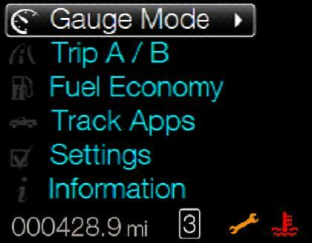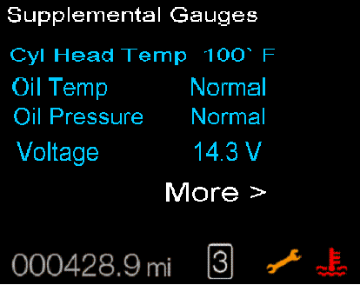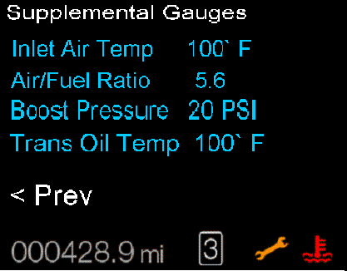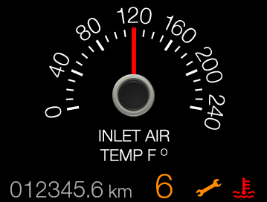

Indicator Color Coordinates

None

HMI-REQ-298750/A-Indicator Characteristics

Description of Gauge | Scale Range | Scale Span | Operating Span
North American | 0ºF to 240⁰F  -20⁰C to 120⁰C | 0 to 200 angular degrees | -9 to 218 angular degrees symetric to Scale Span

Audio

None

Switch Control Logic

Not Applicable

PFM-REQ-298769/A-System Accuracy

- Shall indicate the data contained in EngAirIn_Te_Actl Signal.

Operation: Performance and Functional

Subsystem Algorithm Flowchart / State Diagram

F-REQ-298751/A-Inlet Air Temp Display Configuration

F-REQ-298752/A-Inlet Air Temperature Display Process

F-REQ-298753/A-Inlet Air Temperature Virtual Gauge Display Process

HMI-REQ-298754/A-Inlet Air Temperature Numeric\Virtual Gauge Display

Metric Gauge with min - mid - max pointer positions shown.
min to max operating span = 218 angular degrees.

Operation Description (supports algorithm flowchart /state diagram)

F-REQ-298755/A-EngAirIn_Te_Actl Signal Missing\Unknown
- Gauge pointer shall move to the min pointer position ("Rest Position") at max rate when EngAirIn_Te_Actl is declared missing or invalid as per section 1.4, or EngAirIn_Te_Actl is received with Unknown data (0x3FE).

F-REQ-298756/A-Virtual Gauge Display Needle Waver
- The Inlet Air Temperature virtual Gauge display shall not exhibit needle waver exceeding 1/3 of an angular degree with a steady commanded input.

F-REQ-298757/A-Gauge Pointer Overshoot Limitations
- Pointer overshoot and return to temperature indicated by contained in EngAirIn_Te_Actl Signal shall not exceed one angular degree.

F-REQ-298758/A-Inlet Air Temperature Gauge Display Signal Sampling
- The Inlet Air Temperature display and virtual Gauge display shall sample the contained in EngAirIn_Te_Actl Signal at the predefined message's periodic rate.

F-REQ-298759/A-Virtual Gauge Pointer Position Refreshing Rate
- The cluster shall update the virtual gauge pointer position at least every 100 msec since the Inlet Air temp virtual gauge has a high degree of pointer movement.

F-REQ-298760/A-Inlet Air Temp Gauge Pointer Target Position Calculations
- The cluster shall linear interpolate between input values to calculate the target position to ensure smooth pointer movement between targets.

F-REQ-298761/A-Inlet Air Temp Gauge Display Disabled Configuration
- The Inlet Air Temperature display and the virtual gauge shall not be displayed if Inlet_Air_Temp_display_Cfg is Disabled (0x0).

FS-REQ-298771/A;1-Function Safety Classification (EMC)

B

NVM-REQ-298763/A-Memory Storage

Parameter Name | Description | Value at  Battery Connect | Value at  Module Wake-up
Inlet Air Temperature Display | Displays the numerical value of the cylinder head temperature in selected units. | Inactive | Inactive
Inlet Air Temperature Virtual Gauge display | Use to display virtual Oil Pressure gauge display | Inactive | Inactive
EngAirIn_Te_Actl Signal | CAN signal sent from the PCM for Inlet Air Temperature | -128 C (0x0) | -128 C (0x0)
Virtual_Gauge_Cfg | State indicator for feature presence controlled via CAN at EOL at VO plant. Set to Disabled at Cluster Supplier Manufacturing Plant | Use Stored Value | Use Stored Value
Operational_Mode | 4 state indicator for cluster operational mode | Limited | Limited, Normal or Crank

Prove Out

No

Error Handling

Missing Message Strategy

Signal Missing Strategy
The signals will be declared missing as per the Diagnostics section of this SPSS.

DTCs States Strategy
DTCs states and history will be determined as per the Diagnostics section of this SPSS.

SR-REQ-298764/A-Missing Message DTC Log Disabled
If Inlet_Air_Temp_display _Cfg = Disabled, the cluster shall never log a missing message DTC due to this feature.

Invalid Message Strategy

Signal Invalid Strategy
The signal data will be declared invalid as per the Diagnostics section of this SPSS.

DTCs States Strategy
DTCs states and history will be determined as per the Diagnostics section of this SPSS.

SR-REQ-298765/A-Invalid Message DTC Log Disabled
If Inlet_Air_Temp_display _Cfg = Disabled, the cluster shall never log an invalid data DTC due to this feature.

Diagnostics

Self Test
None.

Engineering Test Mode

Reference section “Dealer / Engineering Test Mode (ETM)”

Part II Performance

DTC-REQ-298766/A-Supported Diagnostic Trouble Codes (DTCs)

DTC | Description
C10000 | Lost Communication with PCM
C40100 | Invalid Data Received from PCM

DCR-REQ-298767/A-DID DE0X

Block  Num | Block Description | Size (bits) | Byte | Bit | State: Description | "0" | "1" | Default | Comments
PACKETED BLOCKS
$XX | Option Content (B&A) | 1 | * | * | Inlet Air Temp Display | Disabled | Enabled | Disabled
*Byte and bit location to be identified in Part II Specification for this cluster

Reference Specification

- Func. Criticality EC-0048
- Mod. PWR-up / Reset EC-0049
- Low-High Vol. Perform. EC-0058
- Jump Start EC-0062
- Instr. & Gauges (indic. Grad) IS-0015
- Oper. Voltage Perf. IS-0052
- Oper. Voltage Func. IS-0053
- Sys. Audible Noise IS-0103
- Pointer Waver IS-0108
- Instr. Scale Dir. IS-0127
- Symbol Usage 01-0238 / 01-0239
- Symbol Leg. 01-0240
- Placement - Parts Loc. 03-0001
- Glare/Reflections 16-0068
- Reflection 17-0018
- Harmony: Graphics / Font / Ill. 17-0040
- Ergo - Access. 17-0052
- Ergo - Operablility 17-0053
- Control & Display Loc. 17-0060
- Logical grouping Function and Usage 17-0062
- Assoc. of Controls with Disp. & elem. 17-0063
- Ill. Controls & Disp. 17-0074
- Id. Legibility 17-0081
- ID. Coding / Labeling 17-0083
- Logic of Op. 17-0120
- Op. Stereotypes 17-0121
- Interpretation 17-0122
- Feedback 17-0124

Revision History
SPSS Module Revision History

Revision Level | Name | Change Description | Date
1.0 | V.Patel | Initial release for CGEA 1.3, based on Inlet Air Temperature Gauge Display S197 v2.0 STSS dated March 30, 2012. | 9/24/2012
1.1 | Mlenkner | Changed Virtual_Gauge_Cfg to Inlet_Air_Temp_display_Cfg throughout | 12/11/12
1.2 | schapeki | Figure 1 update to DE0x and Inlet Air Temp Display  Add figure 2  1.5.3 update DE0x to use Inlet Air Temp Display bit | 6/13/2013
1.3 | A. Mishra | Initial VSEM RM Document | 2/26/2018

